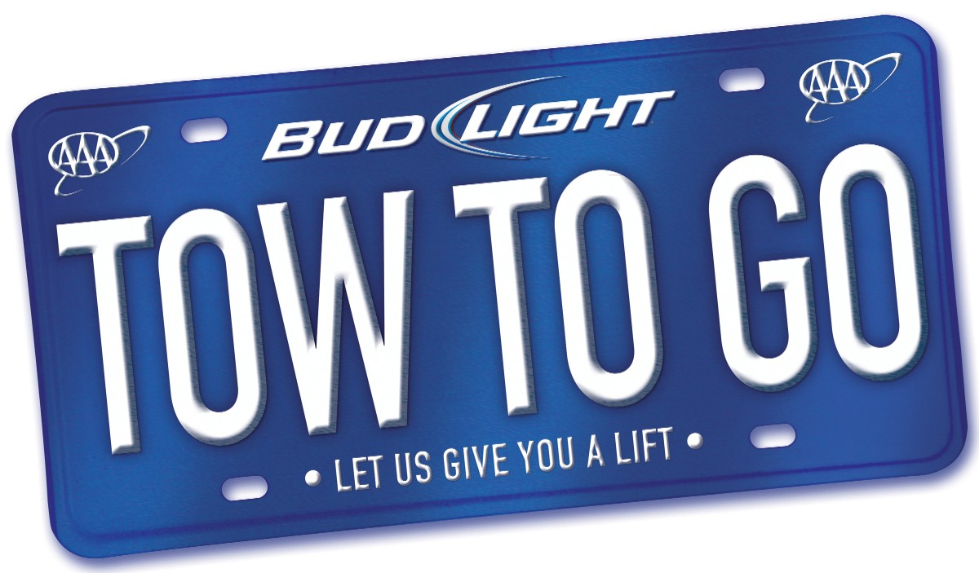 | 2016 TOW TO GO FACT SHEET  A Partnership between AAA & Bud Light

Since its inception in 1998, Tow to Go has safely removed more than 24,000 impaired drivers from the roads. This service is designed to be used as a last resort and is offered based on the availability of AAA Service Technicians and tow trucks during times of high call volume.
- Confidential local ride within a 10-mile radius to a safe location
- Service is provided in Florida, Georgia and Tennessee
- Free and available to both AAA members and non-members
- The AAA tow truck takes the vehicle and the driver home
Tow to Go Service Areas | Toll Free Phone Number
All of Florida, Georgia, and Tennessee | (855) 2-TOW-2-GO or (855) 286-9246
2016 Tow to Go Holiday Schedule

Holidays |  | Date (Day) of Holiday |  | Days/Times Tow to Go is Provided
Super Bowl |  | February 7th (Sunday) |  | February 5th – 6 a.m. on February 8th
St. Patrick's Day |  | March 17th (Thursday) |  | March 17th – 6 a.m. on March 18th
Cinco de Mayo |  | May 5th (Thursday) |  | May 5th – 6 a.m. on May 6th
Memorial Day |  | May 30th (Monday) |  | May 27th – 6 a.m. on May 31st
Independence Day |  | July 4th (Monday) |  | July 1st – 6 a.m. on July 5th
Labor Day |  | September 5th (Monday) |  | September 2nd – 6 a.m. on September 6th
Halloween |  | October 31st (Monday) |  | October 28th – 6 a.m. on November 1st
Thanksgiving |  | November 24th (Thursday) |  | November 23rd – 6 a.m. on November 27th
Christmas  New Year’s Eve |  | December 25th (Sunday)  December 31st (Saturday) |  | December 23rd – 6 a.m. on January 2nd

The Auto Club Group Traffic Safety Foundation and Bud Light provide the Tow to Go service to discourage an impaired driver from getting behind the wheel and risking the lives and safety of other motorists. Not only does Tow to Go remove the impaired driver, it also enables AAA and Bud Light to remind the public to always choose a designated driver for a safe ride home.

Important Tow to Go guidelines:
- Tow trucks can take up to two people home. If there are more people in your party, you will need to make other arrangements to get home safely.
- You can’t make an appointment to use the Tow to Go service, it is designed to be used as a last resort. So choose a designated driver before you have your first drink.
- It may be necessary, in certain situations, for AAA to contact a cab company or local law enforcement to assist with getting an impaired individual a safe ride home.
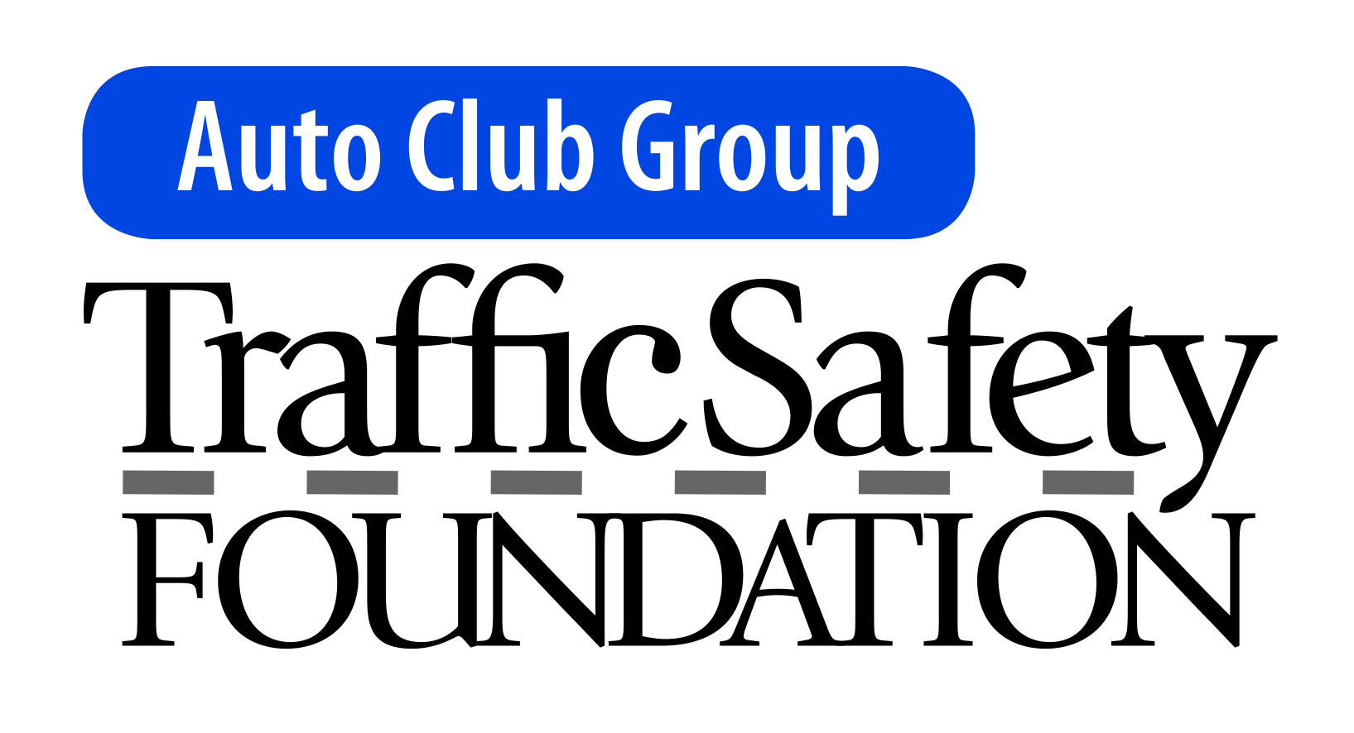 | Tow to Go is a program of the Auto Club Group Traffic Safety Foundation. The mission of the Foundation is to produce a significant and continuous reduction in traffic crashes, injuries and deaths in the communities targeted by our efforts.

