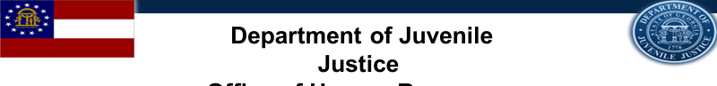
Georgia Department of Juvenile Justice
HIRING EVENT
for
Juvenile Correctional Officer at the
Wilkes Regional Youth Detention Center
WHEN: Thursday, January 11, 2018

WHERE: Pope Center
48-B Lexington Avenue
Washington, GA 30673

TIME: 10:00AM – 2:00PM

ATTIRE: Business Professional

WHAT TO BRING
To ensure eligibility for entrance and interviewing you MUST bring the following:
- Completed Georgia State Merit Application
- Valid Georgia Driver’s License
- Social Security Card
- Certified Birth Certificate
- Proof of High School Diploma or GED
- Test Scores (ACT, SAT, Compass, or Accuplacer) or Proof of 4-year degree from an accredited college or university
- DD214 long form with indicated discharge (Military Personnel Only)
- POST Certification (if applicable)
- Naturalization forms if non- US citizen

This event is open to the public

*Professional dress for onsite interviews is required; current law enforcement and Military personnel may come in uniform*

